**• What is React Js?**

React is a **JavaScript** library created by **Facebook**

React is a **User Interface** (UI) library

React is a tool for building **UI components**

**• What is NPM in React Js?**

**npm** is the world's largest **Software Library** (Registry)

**npm** is also a software **Package Manager** and **Installer**

**npm** can manage **dependencies**.

**npm** can (in one command line) install all the dependencies of a project.

Dependencies are also defined in **package.json**.

**• What is Role of Node Js in react Js?**

React js uses Node.js, a JavaScript runtime, to**build your JavaScript code**. Node.js is a server-side JavaScript runtime environment. React js ships with some tools that are written for Node.js. Node.js is an open source platform built on Chrome's JavaScript runtime; it offers a way to easily build fast, scalable programs.

**• What is CLI command In React Js?**

Let us learn the basic command available in Create React App command line application in this chapter.

Creating a new application

*Create React App provides* multiple ways to create React application.

Using *npx* script.

npx create-react-app <react-app-name>

npx create-react-app hello-react-app

Using *npm* package manager.

npm init react-app <react-app-name>

npm init react-app hello-react-app

Using *yarn* package manager.

yarn init react-app <react-app-name>

yarn init react-app hello-react-app

Selecting a template

*Create React App* creates React application using default template. Template refers the initial code with certain build-in functionality. There are hundreds of template with many advanced features are available in npm package server. *Create React App* allows the users to select the template through *–template* command line switch.

create-react-app my-app --template typescript

Above command will create react app using *cra-template-typescript* package from npm server.

Installing a dependency

React dependency package can be installed using normal *npm* or *yarn* package command as React uses the project structure recommended by *npm* and *yarn*.

Using *npm* package manager.

npm install --save react-router-dom

Using *yarn* package manager.

yarn add react-router-dom

Running the application

React application can be started using *npm* or *yarn* command depending on the package manager used in the project.

Using *npm* package manager.

npm start

Using *yarn* package manager.

yarn start

To run the application in secure mode (HTTPS), set an environment variable, *HTTPS* and set it to true before starting the application. For example, in windows command prompt (cmd.exe), the below command set *HTTPS* and starts the application is HTTPS mode.

set HTTPS=true && npm start

**• What is Components in React Js?**

Components are independent and reusable bits of code. They serve the same purpose as JavaScript functions, but work in isolation and return HTML.

Components come in two types, Class components and Function components.

**• What is Header and Content Components in React Js?**

The Header is an important element of a website’s design. It’s the first impression of the website. It provides useful links to other areas of the website that the user may want to visit. In this article, we will create a functioning Header using React.js and Material UI.

**How to install React Js on Windows, Linux Operating System? How to install NPM and How to check version of NPM?**

# **How to Install ReactJS on Windows**?

**=>Step 1**: Install Node.js installer for windows. Click on this [link](https://nodejs.org/en/). Here install the LTS version (the one present on the left). Once downloaded open NodeJS without disturbing other settings, click on the **Next**button until it’s completely installed.

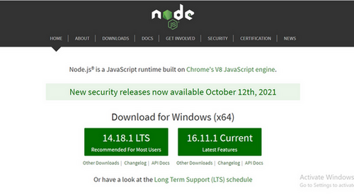

*Install the 14.18.1 LTS*

**=>Step 2**: Open command prompt  to check whether it is completely installed or not type the command –>

node -v

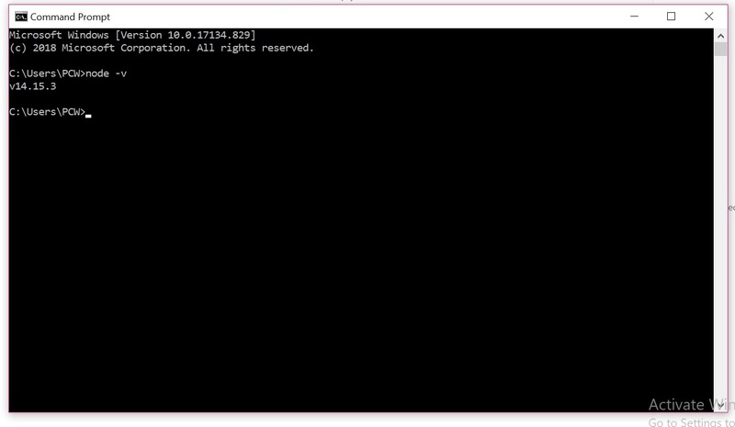

*Node Version is v14.15.3*

If the installation went well it will give you the version you have installed

**=>Step 3**: Now in the terminal run the below command:

npm install -g create-react-app

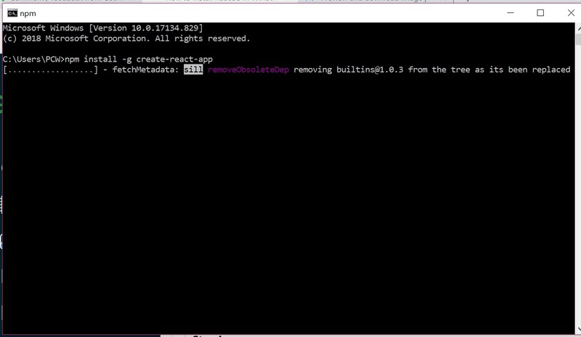

*Installation will take few seconds*

It will globally install react app for you. To check everything  went well run the command

create-react-app --version

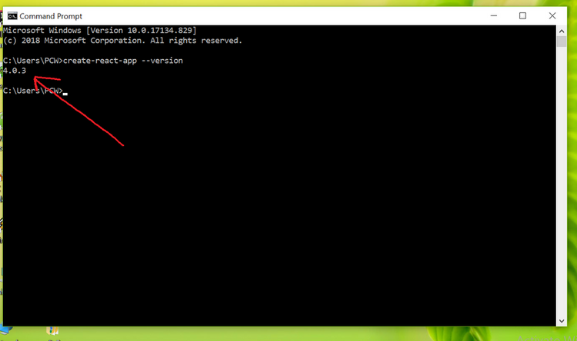

*version  4.0.3*

If everything went well it will give you the installed version of react app

**=>Step 4:**Now Create a new folder where you want to make your react app using the below command:

mkdir newfolder

**Note:** The *newfolder*in the above command is the name of the folder and can be anything.

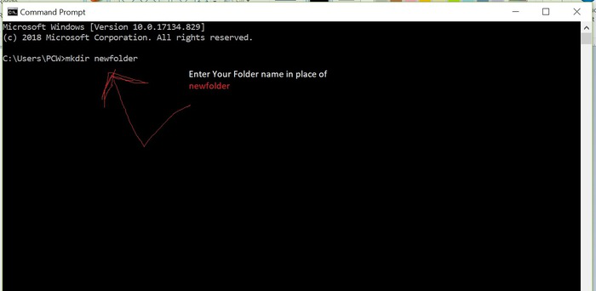

Move inside the same folder using the below command:

cd newfolder (your folder name)

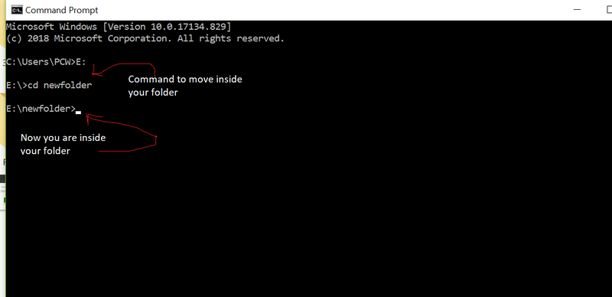

**=>Step 5**: Now inside this folder run the command –>

create-react-app reactfirst YOUR_APP_NAME

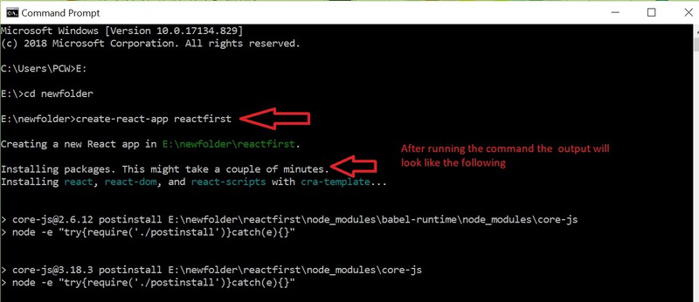

It will take some time to install the required dependencies

**NOTE:**Due to npm naming restrictions, names can no longer contain capital letters, thus type your app’s name in lowercase.

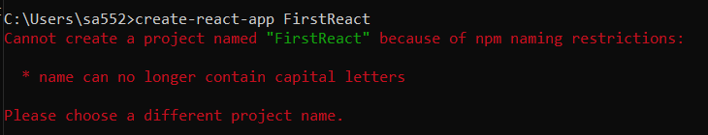

**=>Step 6**: Now open the IDE of your choice for eg.  Visual studio code and open the folder where you have installed the react app **newfolder**(in the above example)  inside the folder you will see your app’s name **reactapp**(In our example). Use the terminal and move inside your app name folder.Use command  **cd reactapp**(your app name)

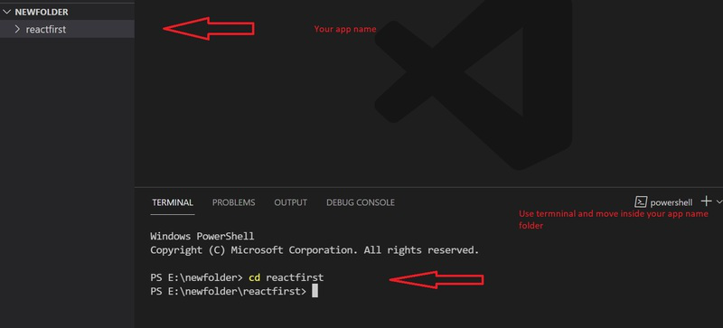

**Step 7:**To start your app run the below command :

npm start

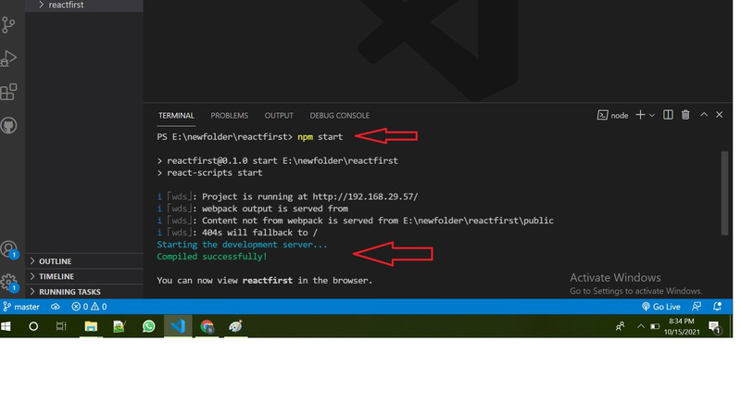

Once you run the above command a new tab will open in your browser showing React logo :

**• How to check version of React Js?**

Just type the below command in your command prompt:

npm view react version